Broker Confirmation — BRK-88402
Broker: North Harbor Environmental Markets. Account: BSC REC Trading Desk.
Physical blotter photograph received with the trade identity shown below. Economic fields remain evidenced by the attached record.
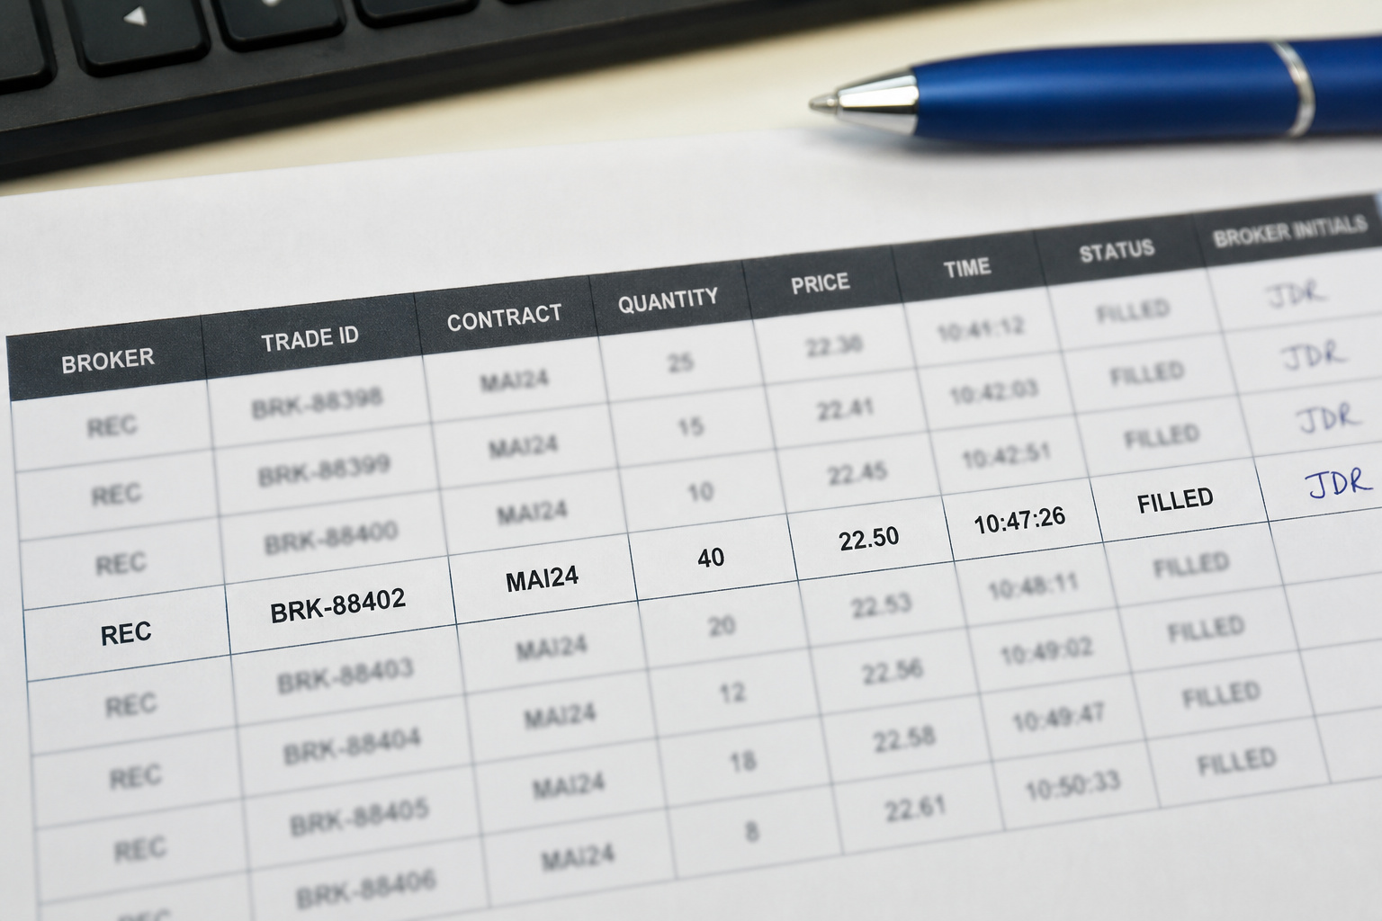
Procurement control copy; accounting linkage is maintained separately.

